**Prabhjot Singh – UI – Project 1 - CinePath**

**About the project:**

For this project I have decided to pick the theme of movies. I want to create an app that allows for users to quickly log, rate, and review movies they have watched. I want my project to have two parts, a recommendation panel and an area where users can click a plus button to quickly add their movie. Since discovery is a big part of movies, the recommendation panel will be basic implementation of banners that display the poster and a small description.

**Interview:**

For this stage I have selected two people to provide me with some input. One of them is familiar with the modern technology and apps and the other barley uses any new apps unless they must. I have also given both individuals a full background of the project and explained limitations such as backend. I told them to both focus on largely user interface elements. Here’s a select few from the discussion.

Person 1: Jason Nagra (Tech savvy person)

Person 2: Simran Gill (Not as tech savvy)

Question: What would you like to see in a personal movie tracker? What are some problems you have with current ones?

1: I prefer simple, clean, and sleek apps. Most trackers are filled with content I don’t care about. I just want a simple add button.

2: I want something that has a singular purpose. I just want to add movies an easily search them, that’s it. Maybe something to show me new releases so I can quickly get ideas.

Question: What type of content would you like to add when tracking a movie?  
1: I want to add the rating and my personal review of the movie.

2: Rating, review, and some notes would be nice.

Question: Anything else other than tracking you would like to see.

1: I want good autofill, like something where I can select a movie title, and I have some basic stuff filled in.

2: Nothing else really, I like it when apps offer a singular/basic purpose.

From these interviews I wanted to know if the UI should look to those that are not as tech savvy. I feel that this goal was accomplished. I asked question mainly about what the user desires if they were picking an app. My participants told me ideas like how they wanted a single purpose app with an easy-to-use UI. I learned the design rules I need to follow for this app.

**Goals:**

1. The easy way to add moves by making the add button should always be visible.
2. A way to quickly search the movies you have recorded.
3. A movie first approaches but still shows recommendations in some way.

**Sketching:**

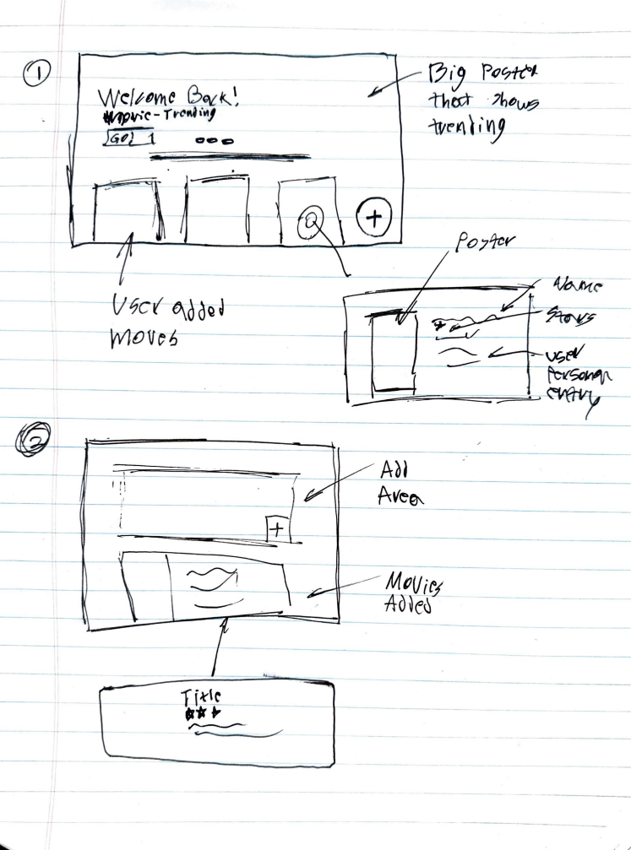

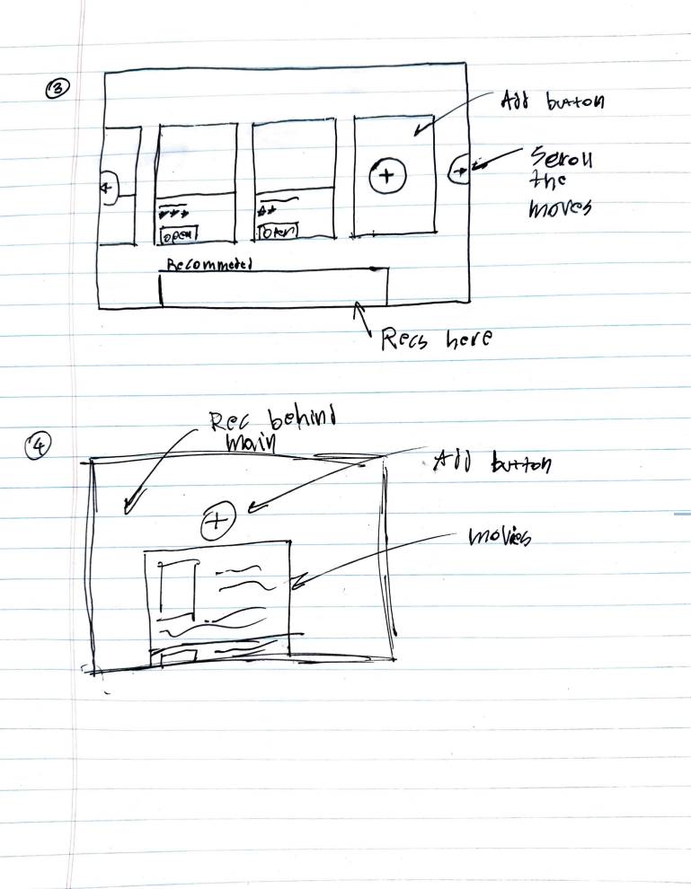

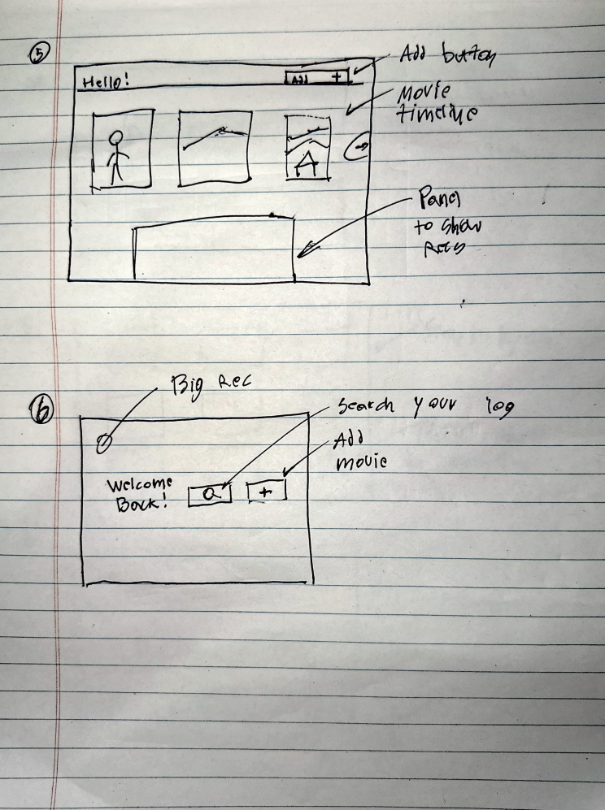

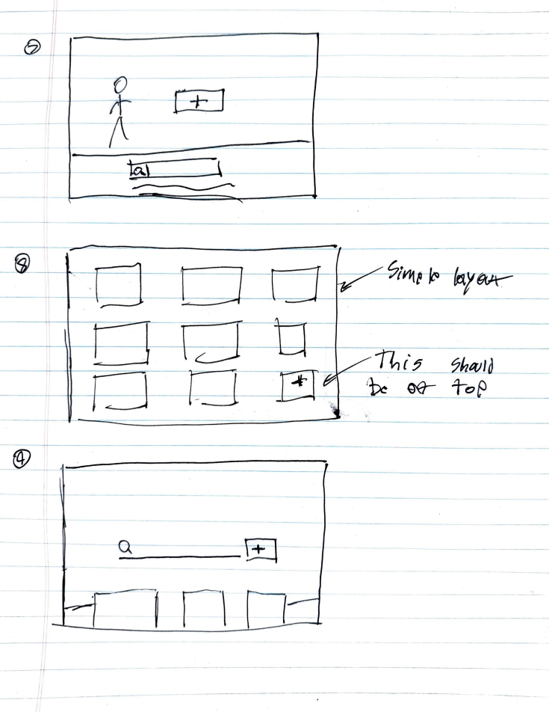

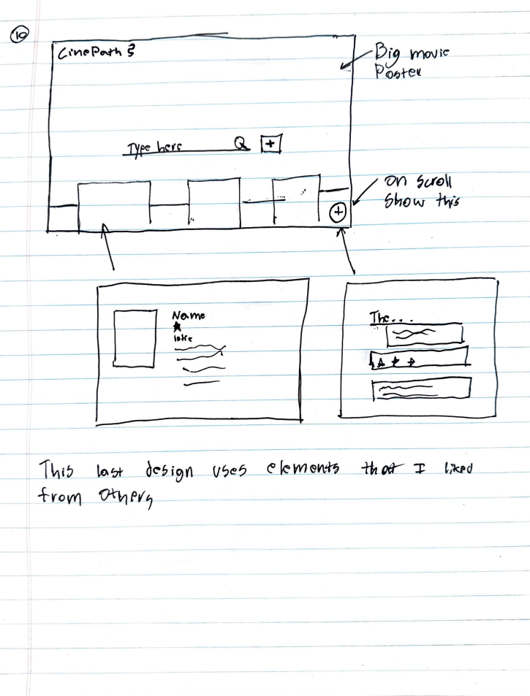

**Feedback:**

Simran Gill: I like these, the add button should always be the main thing. I prefer the last one.

Jason: I am happy about most of these, but I don’t like horizontal scrolling, I think vertical is much better. I will also go with the last one, looks clean and modern.

**Prototype Sketch:**

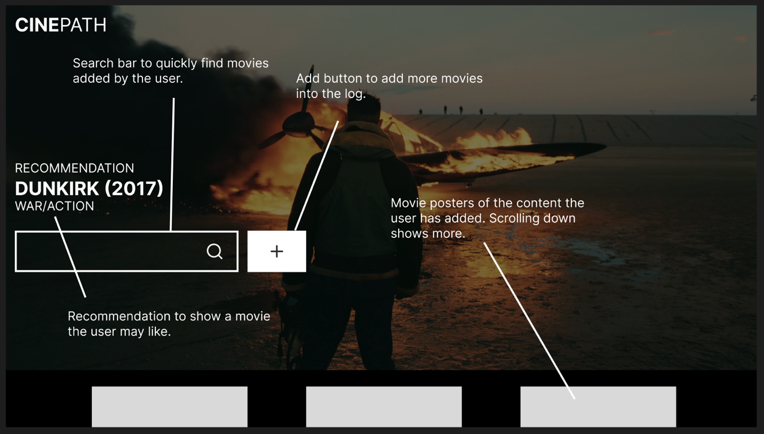

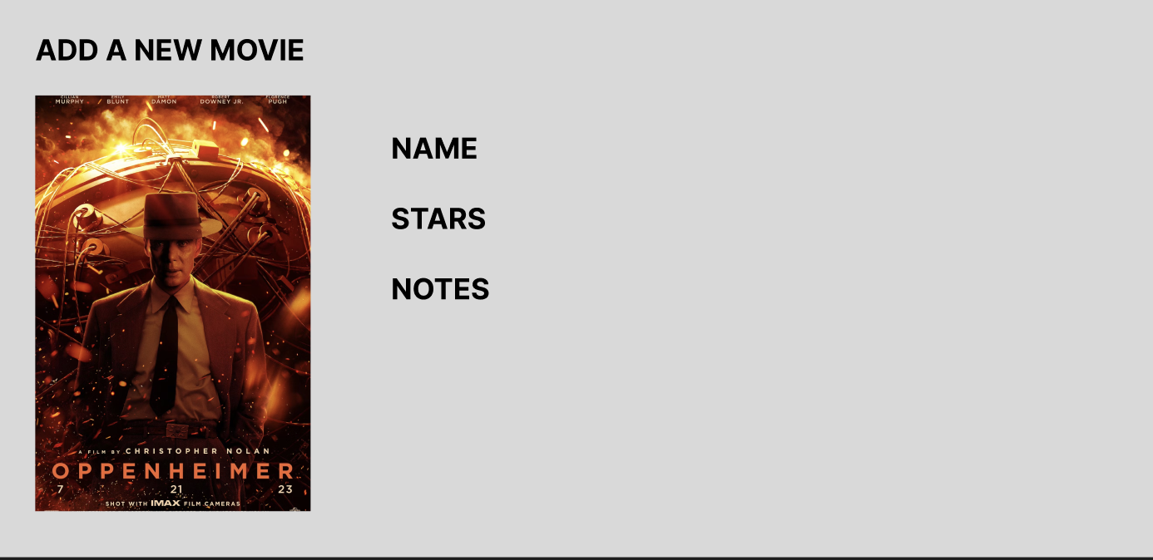

**Feedback:**

Preet G: This looks very nice! I like how it looks like movie apps I am used.

Garry P: If I were log movies, I would want something that looks like this, I am happy with the way this design looks.

Arpit G: This looks nice, I think the add new movies section could use some more work.

**Mock User:**

Mike Smith

Likes watching a lot of movies and has trouble recalling things when friends ask.

Mike would open CinePath and quickly scroll through movies he watched and recommend them and read the notes he left. When watching a movie, he opens the app and hits the big plus button to add a new one.

**Final Requirements:**

Apart from what was described in the implementations, I also added API support to easily search movies and show recommendations. So much of logging movies is based on data that is already out there.

**Final Interface:**

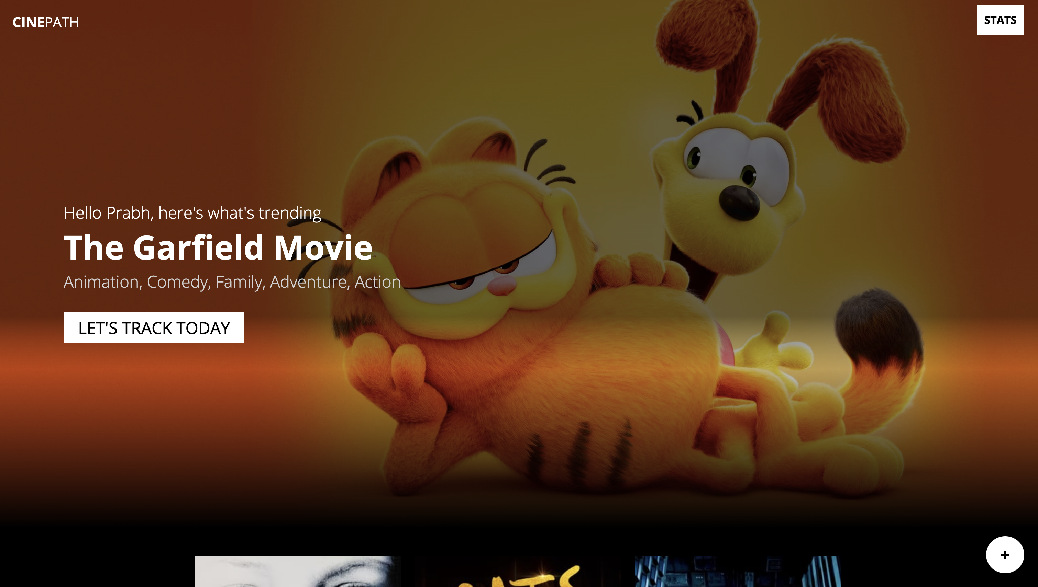

Main welcome screen. Recommendation pulled from trending movies.

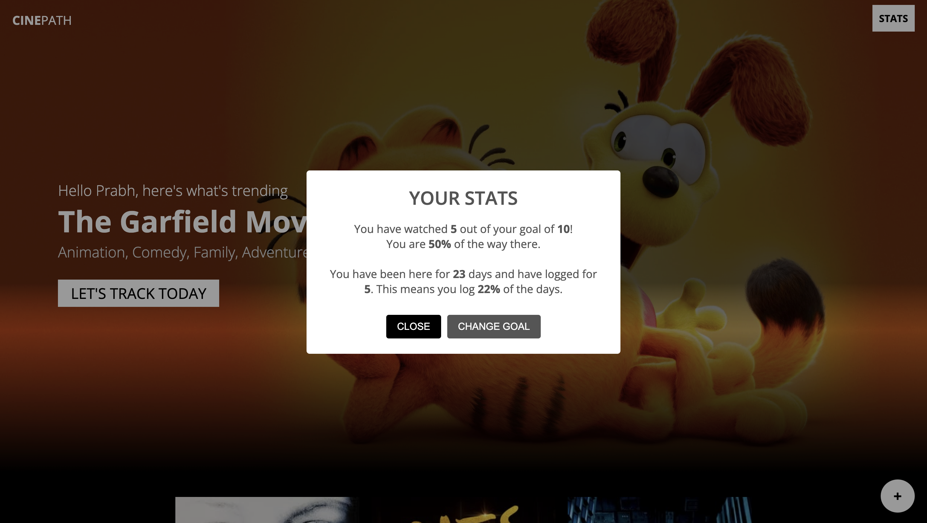

Goals screen, user can also edit their goals here.

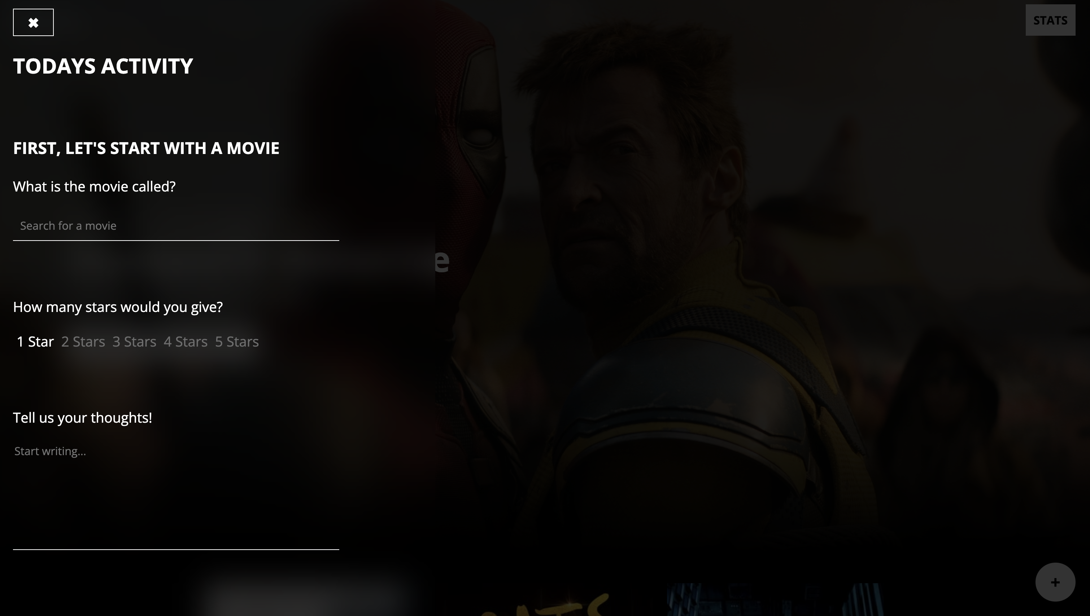

Add activity panel, user can log their movies along with details.

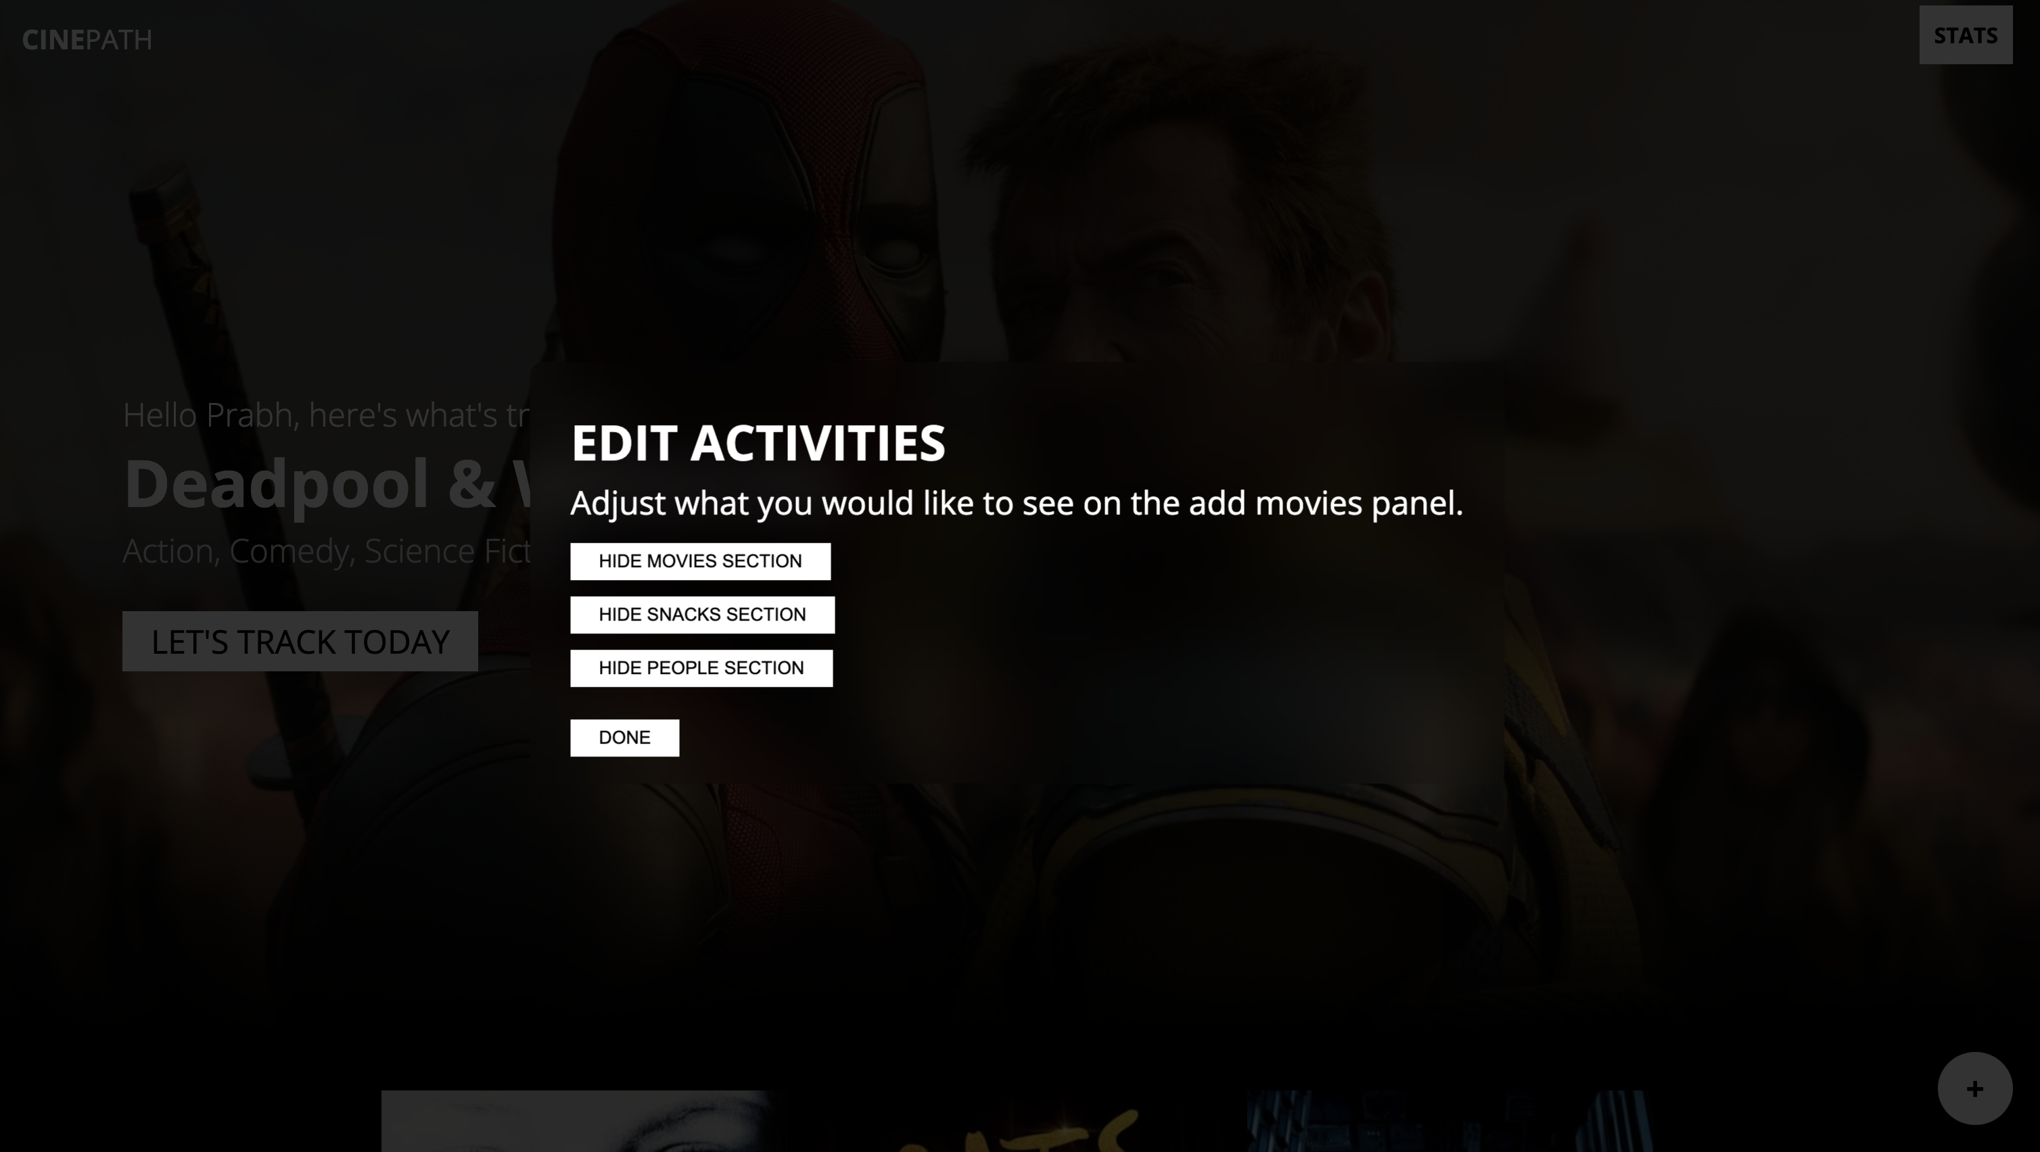

When scrolling to the bottom of the add panel, an edit button is alongside the post button. This allows you to hide or show certain activities.

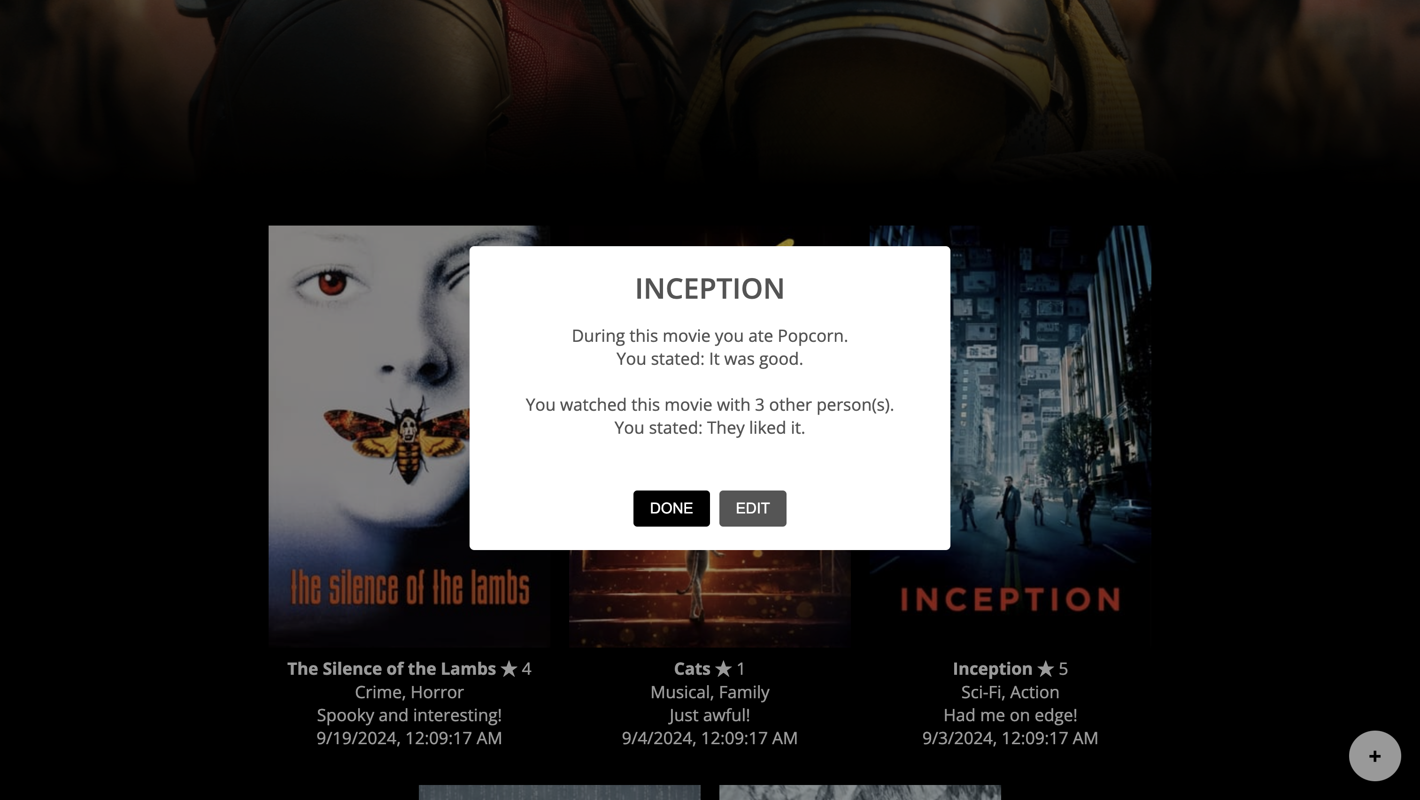

Further movie details. Behind it you can also see all the user added movies.

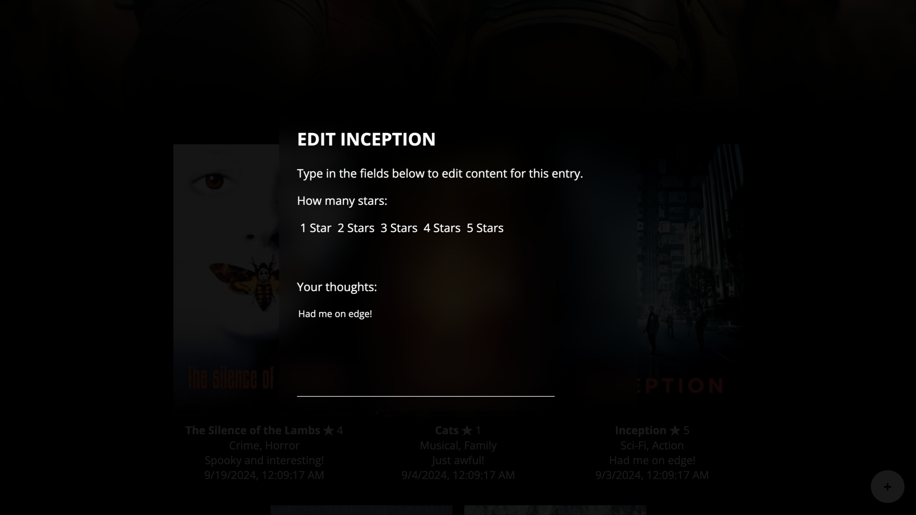

Edit entries screen (more content on scroll but for some reason MAC hides the bar).

This interface is very straightforward, users can quickly add movies and review the content after. The code structure is uses about three components the main app, add movies, and the banner. I created my own UI elements however some of the alerts use a popular library called sweet alerts. With this interface a user can log movies, snacks, and their friends thoughts super easily.

For this project I used AI sometimes. Since the code had multiple components, it was very hard to provide the context to some bugs. However, it helped me solve quick little errors fast.

I don’t plan on doing much in the future for this, it was fun while I worked on it.